PV Connection Direction Fault

Author：胡维
Reviewer：Eason

String INV\Hybrid INV
Issue introduction
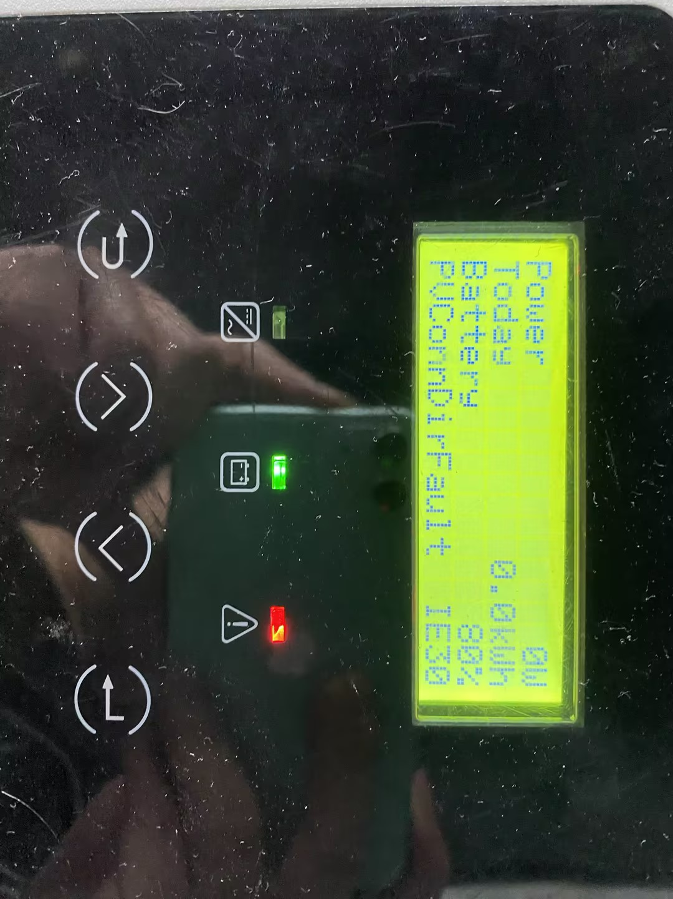
The inverter screen displays：PVConnDirFault
Confirmation of basic information
[Photo]SN number of the inverter.
Guidance for installer
Measuring the voltage on the PV side with a multimeter, ensure the red probe is connected to the positive terminal and the black probe to the negative terminal. The correct measurement should be a positive number within the MPPT range. If a negative number appears, it indicates that the PV wires are reversed.
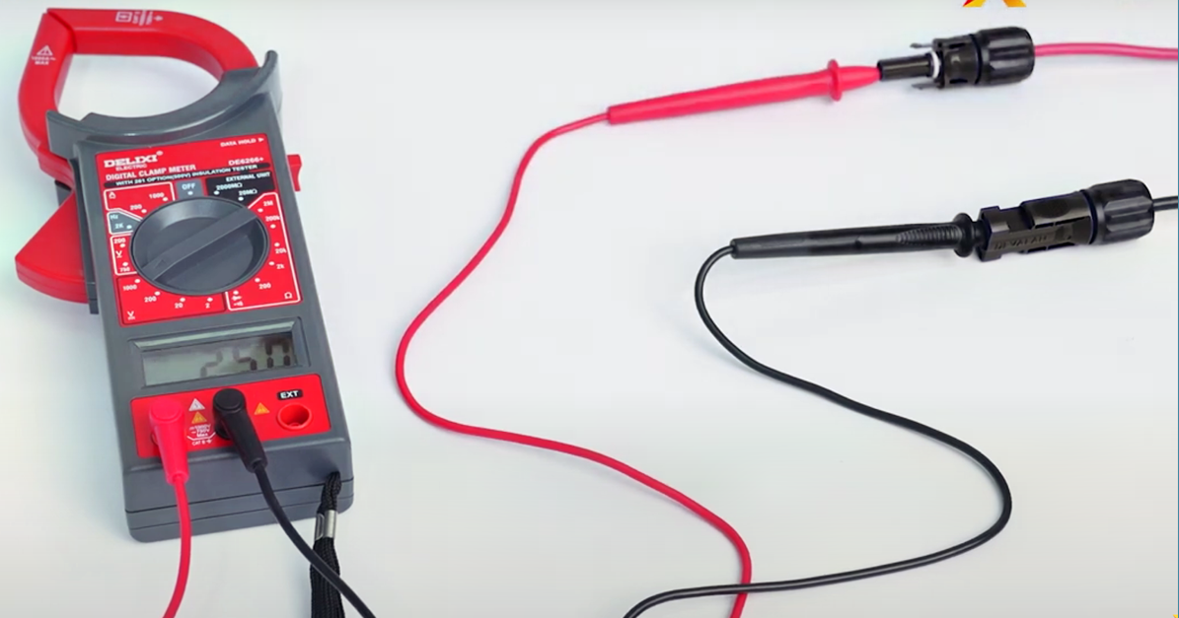
If the voltage difference between two strings of PV panels within the same MPPT is too large, it can also cause this error. Therefore, try to ensure that each string has the same number of PV panels, and ideally, keep the voltage difference between strings within 200 volts.
Information check list
If you have completed the above <Guidance for installer>, and the problem is still not solved, please collect the following troubleshooting information and send them to the R&D.
- [Photo]SN number of the inverter.
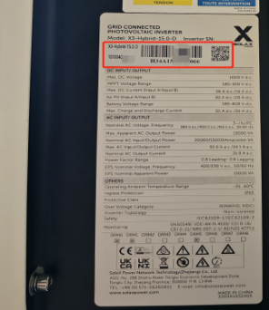
- [Photo]Measurements of PV voltage per string.

